**Ideation Phase**

**Brainstorm & Idea Prioritization Template**

|  |  |
| --- | --- |
| Date | 30-10-2025 |
| Team ID | NM2025TMID07992 |
| Project Name | Optimizing User, Group, and Role Management with Access Control and Workflows |
| Maximum Marks | 4 Marks |

**Brainstorm & Idea Prioritization :**

Brainstorming sessions were held to produce ideas for enhancing workflow efficiency and access control in order to overcome the difficulties in managing users, groups, and roles inside ServiceNow. To ensure secure data handling, team members investigated a number of options, including automating role assignments, integrating approval workflows, and putting access control lists (ACLs) into place.

Following an assessment of each proposal, the concepts were ranked according to their significance, viability, and simplicity of execution. Using Flow Designer to create approval-based workflows, establishing explicit role hierarchies, and automating user management flows were the key goals.

The team was able to concentrate on the best ways to improve system efficiency, expedite administrative work, and fortify security in the ServiceNow environment thanks to this cooperative brainstorming approach.

**Step-1: Team Gathering, Collaboration and Select the Problem Statement**

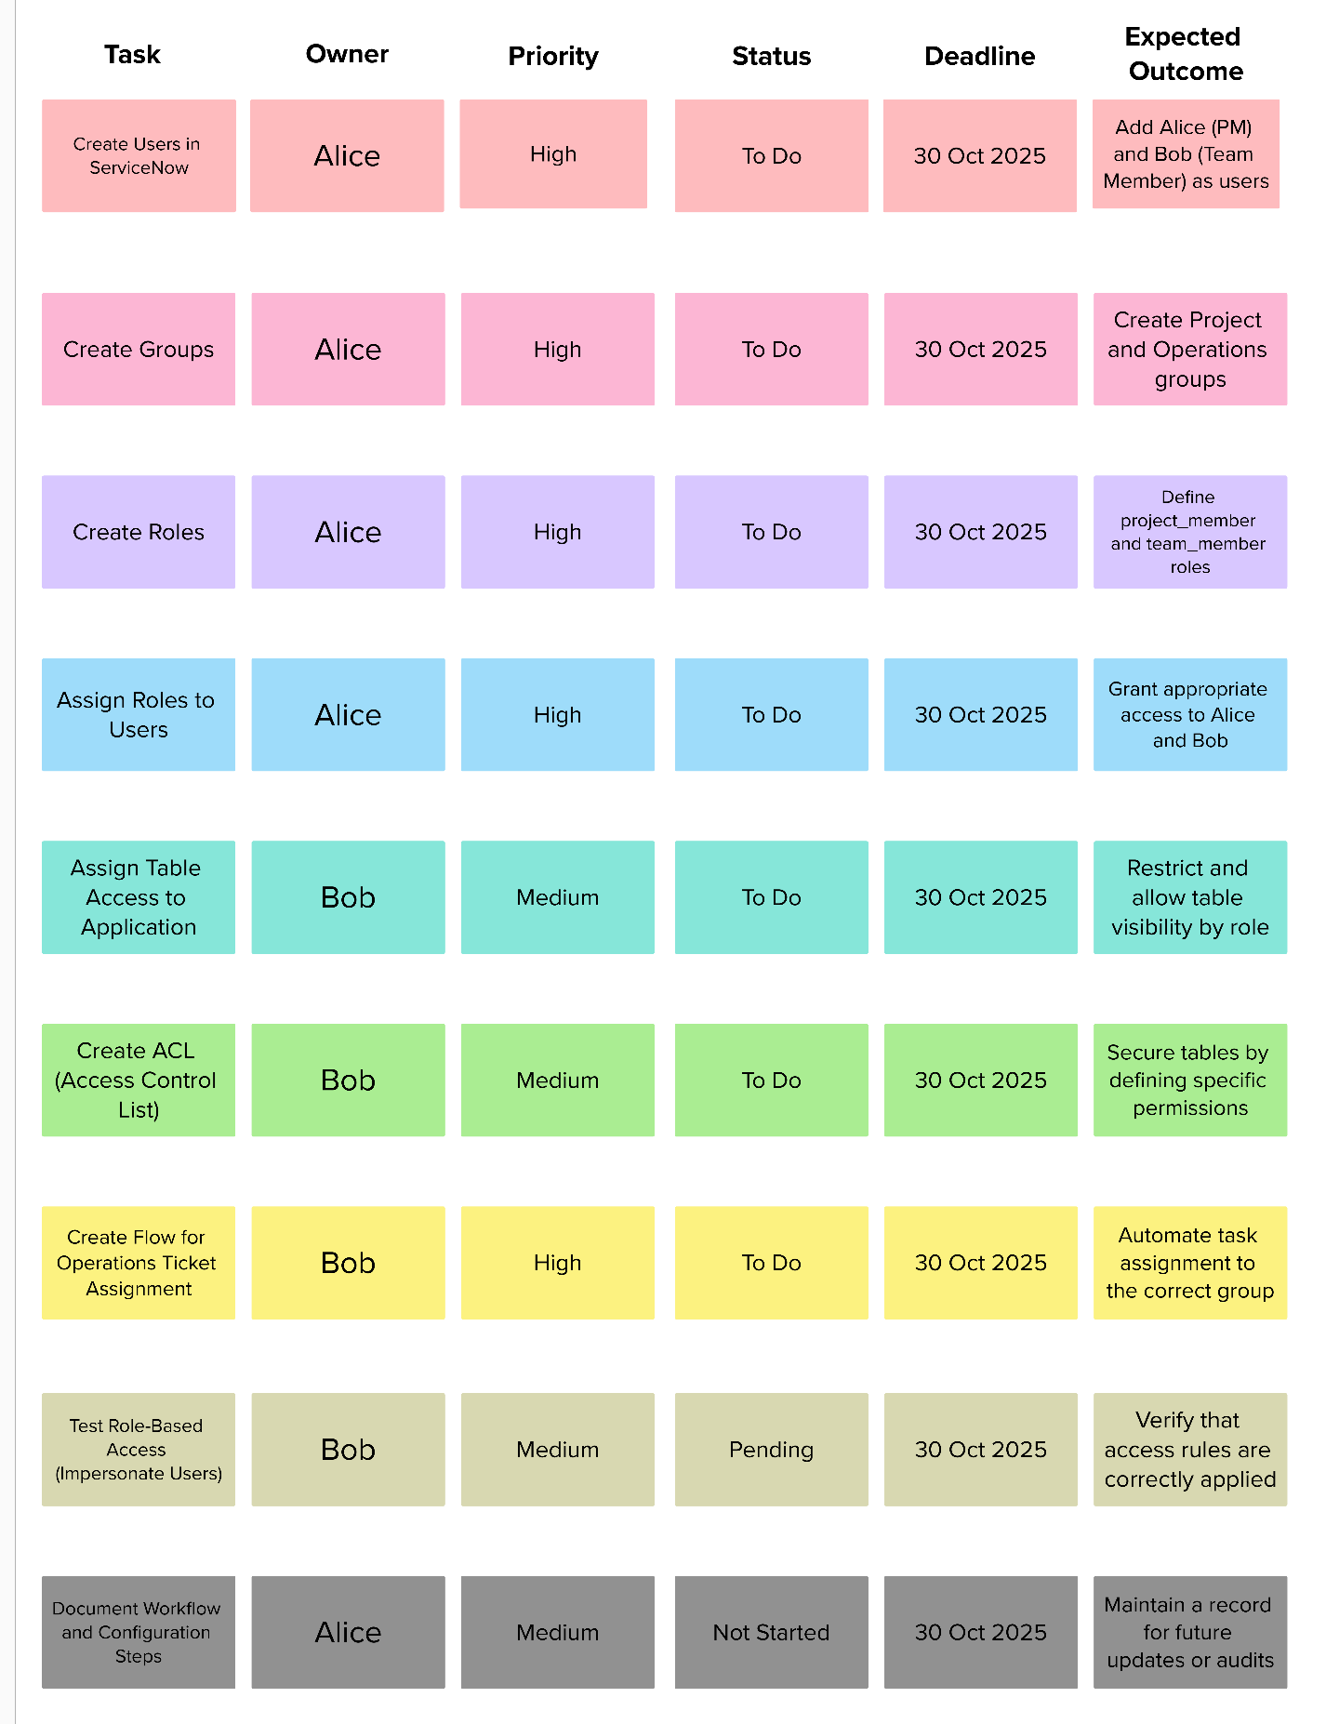

**Step-2: Brainstorm, Idea Listing, Grouping and Idea Prioritization**

